Milestone 5 : Creation of Access Control Lists(Write ACL)

Click New to create a new ACL(Write)
- Enter the following details:
  - Type: record
  - Operation: Write
- Name: u_institution_details
  - Active: true
- In the Requires role related list, add:
  - bb3 (custom role)
- No need to add any Data condition
- Save the ACL Record
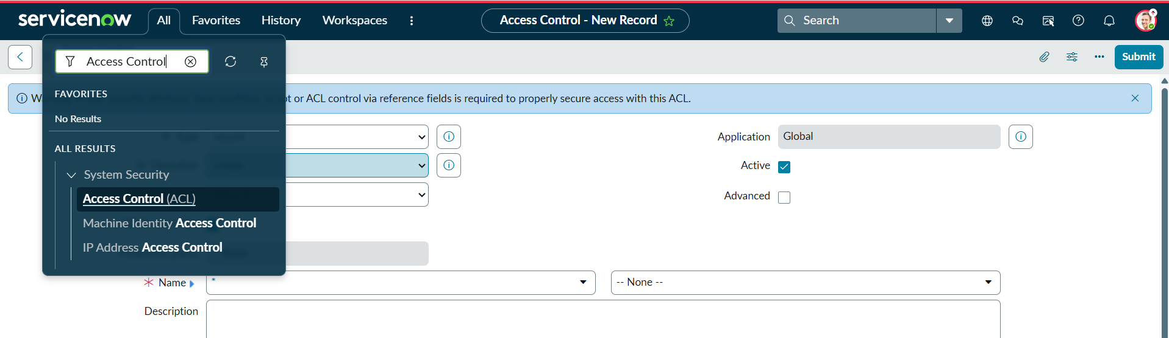
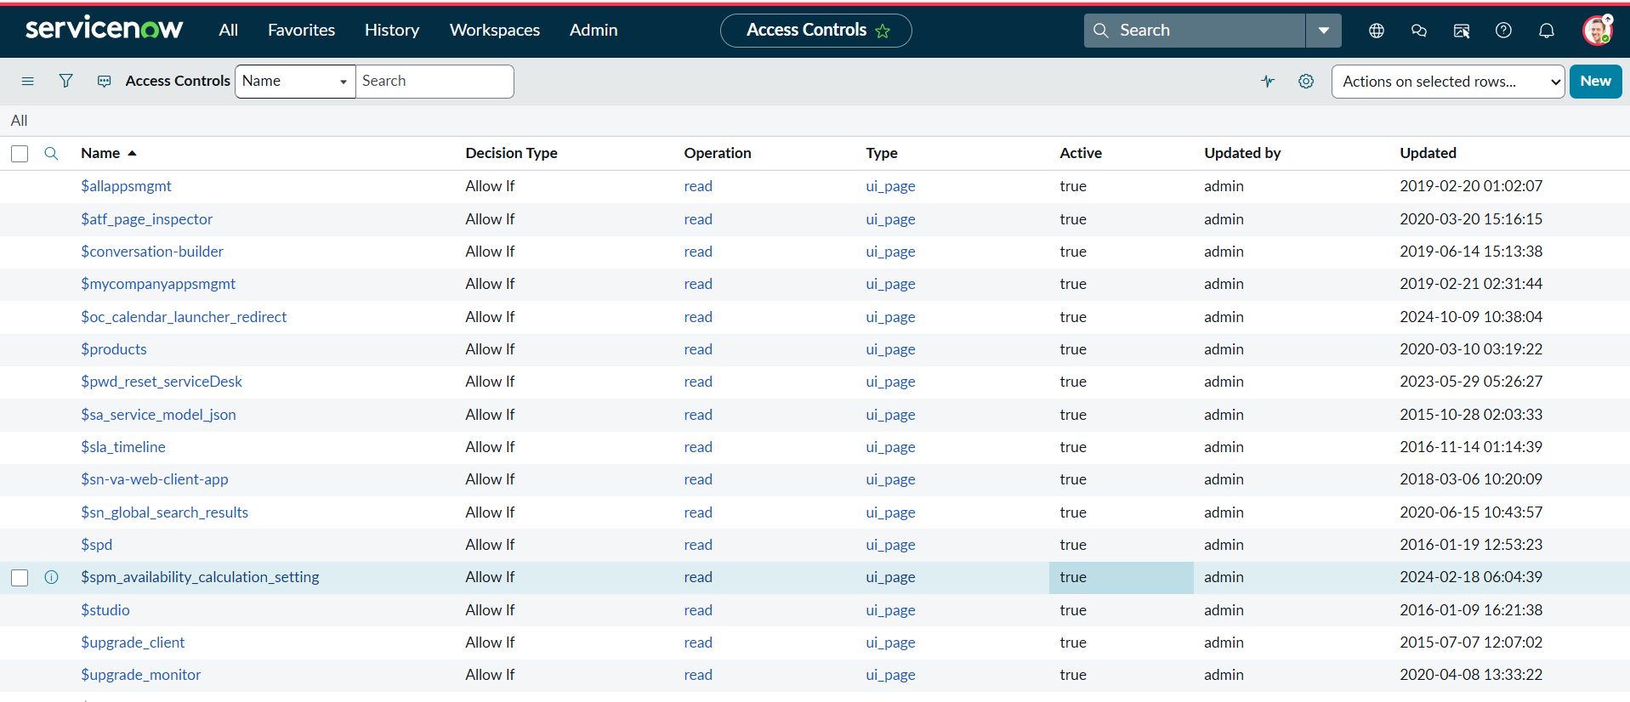
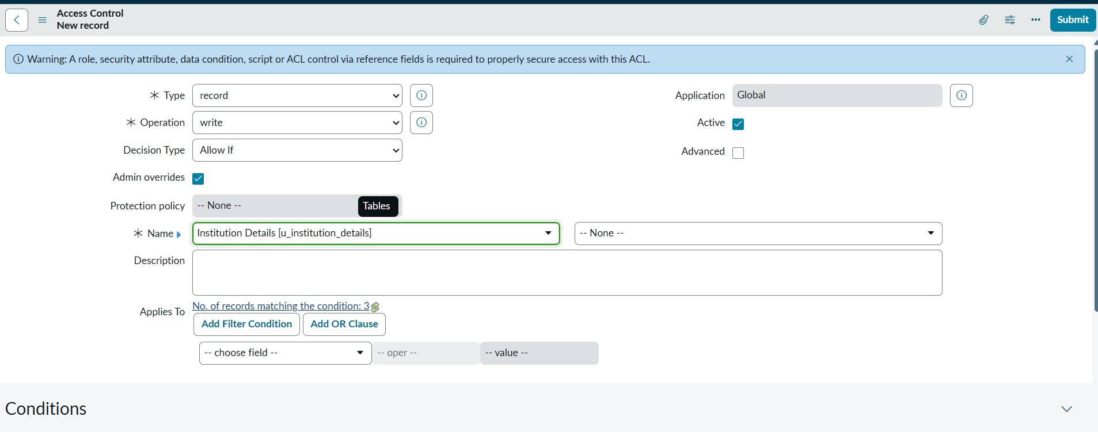
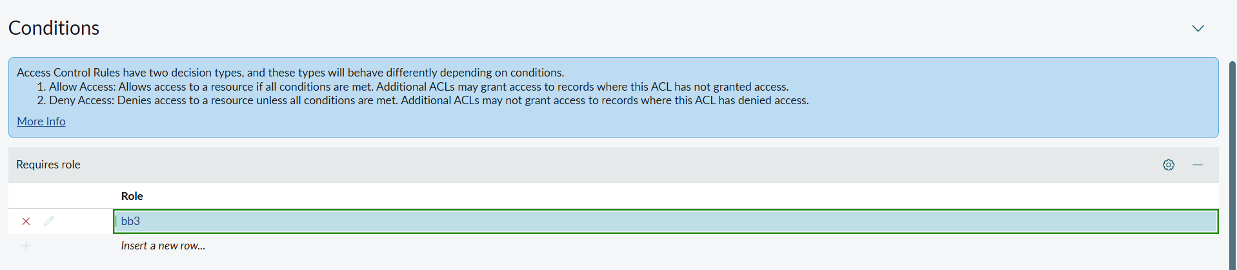

Verify :
- User with bb1 &bb2 &bb3 roles can view and edit the EEE branch records along with New Button

